Thomas Nguyen

Coen 171

T R 5:40 – 7:20

Homework # 2

**3.2a Write EBNF descriptions for the following: A Java class definition header statement**

<head> -> {<modifier>} class <id> [extends name]

[implements <interface_name> , {<interface_name>}]

<modifier> -> public | abstract | final

**3.2c Write EBNF descriptions for the following: A C switch statement**

<switch_stmt> -> switch (<expr>) {case <literal> : <stmt_list>

{case <literal> : <stmt_list> } [default : <stmt_list>] }

**3.3 Rewrite the BNF of Example 3.4 to give + precedence over * and force + to be right associative**

<assign> -> <id> = <expr>

<id> -> A | B | C

<expr> -> <expr> * <term>

| <term>

<term> -> <term> + <factor>

| <factor>

<factor> -> ( <expr>)

| <id>

**3.6 Using the grammar in Example 3.2, show a parse tree and a leftmost derivation for each of the following statements:**

**A = A * (B + (C * A))**

<assign> => <id> = <expr>

=> A = <expr>

=> A = <id> * <expr>

=> A = A * <expr>

=> A = A * (<expr>)

=> A = A * (<id> + <expr>)

=> A = A * (B + <expr>)

=> A = A * (B + (<expr>))

=> A = A * (B + (<id> * <expr>))

=> A = A * (B + (C * <id>))

=> A = A * (B + (C * A))

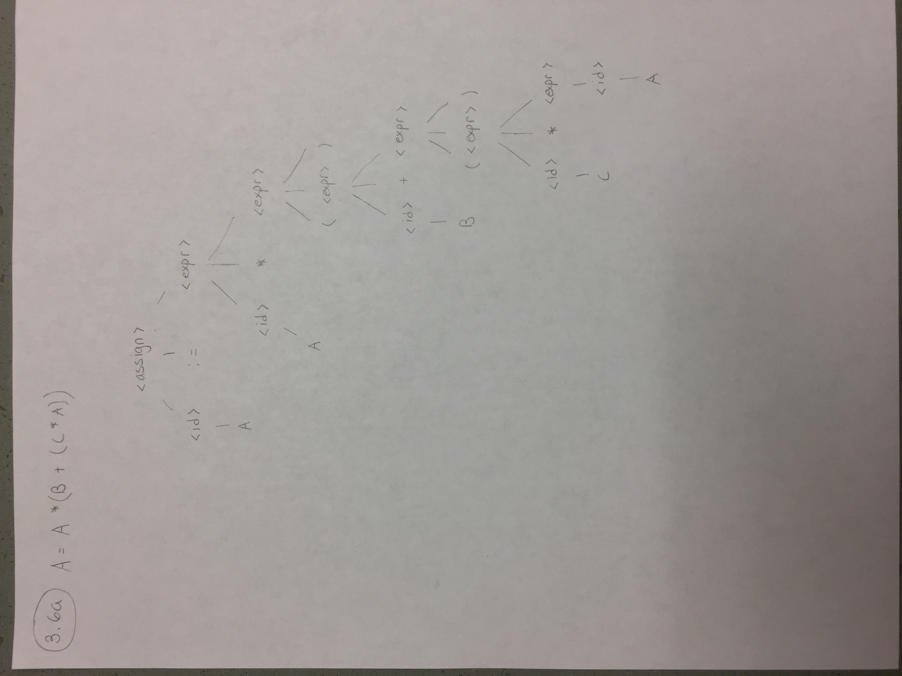

**B = C * (A * C + B)**

<assign> => <id> = <expr>

=> B = <expr>

=> B = <id> * <expr>

=> B = <id> * (<expr>)

=> B = C * (<id> * <expr>)

=> B = C * (A * <expr>)

=> B = C * (A * <id> + <expr>)

=> B = C * (A * C + <id>))

=> B = C * (A * C + B)

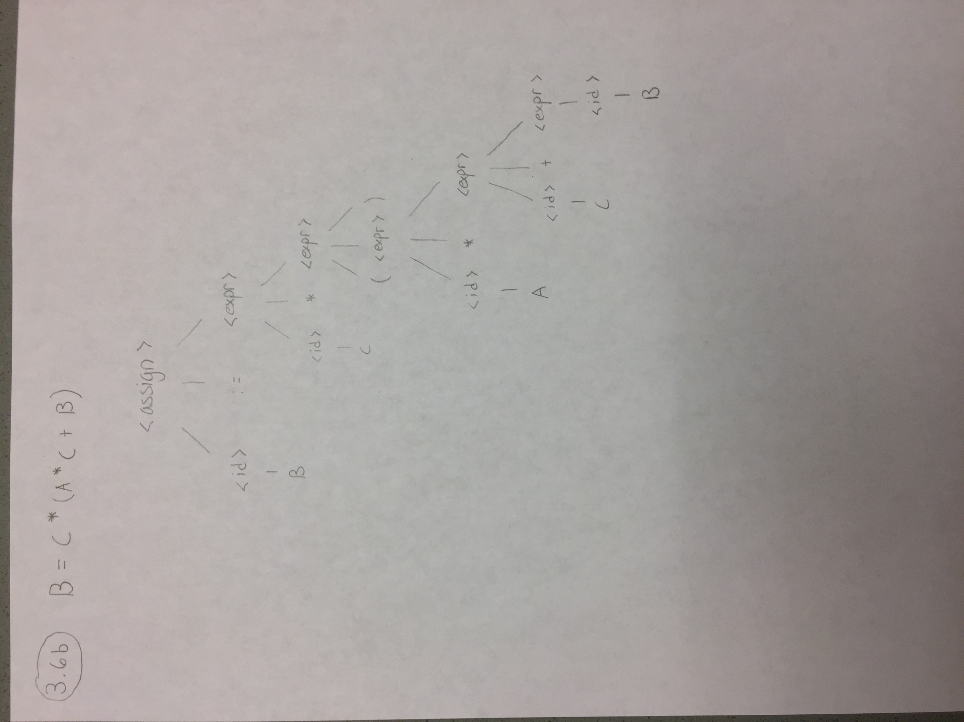

**A = A * (B + ( C ) )**

<assign> => <id> = <expr>

=> A = <expr>

=> A = <id> * <expr>

=> A = A * <expr>

=> A = A * (<expr>)

=> A = A * (<id> + <expr>)

=> A = A * (B + <expr>)

=> A = A * (B + (<expr>))

=> A = A * (B + (<id>))

=> A = A * (B + (C))

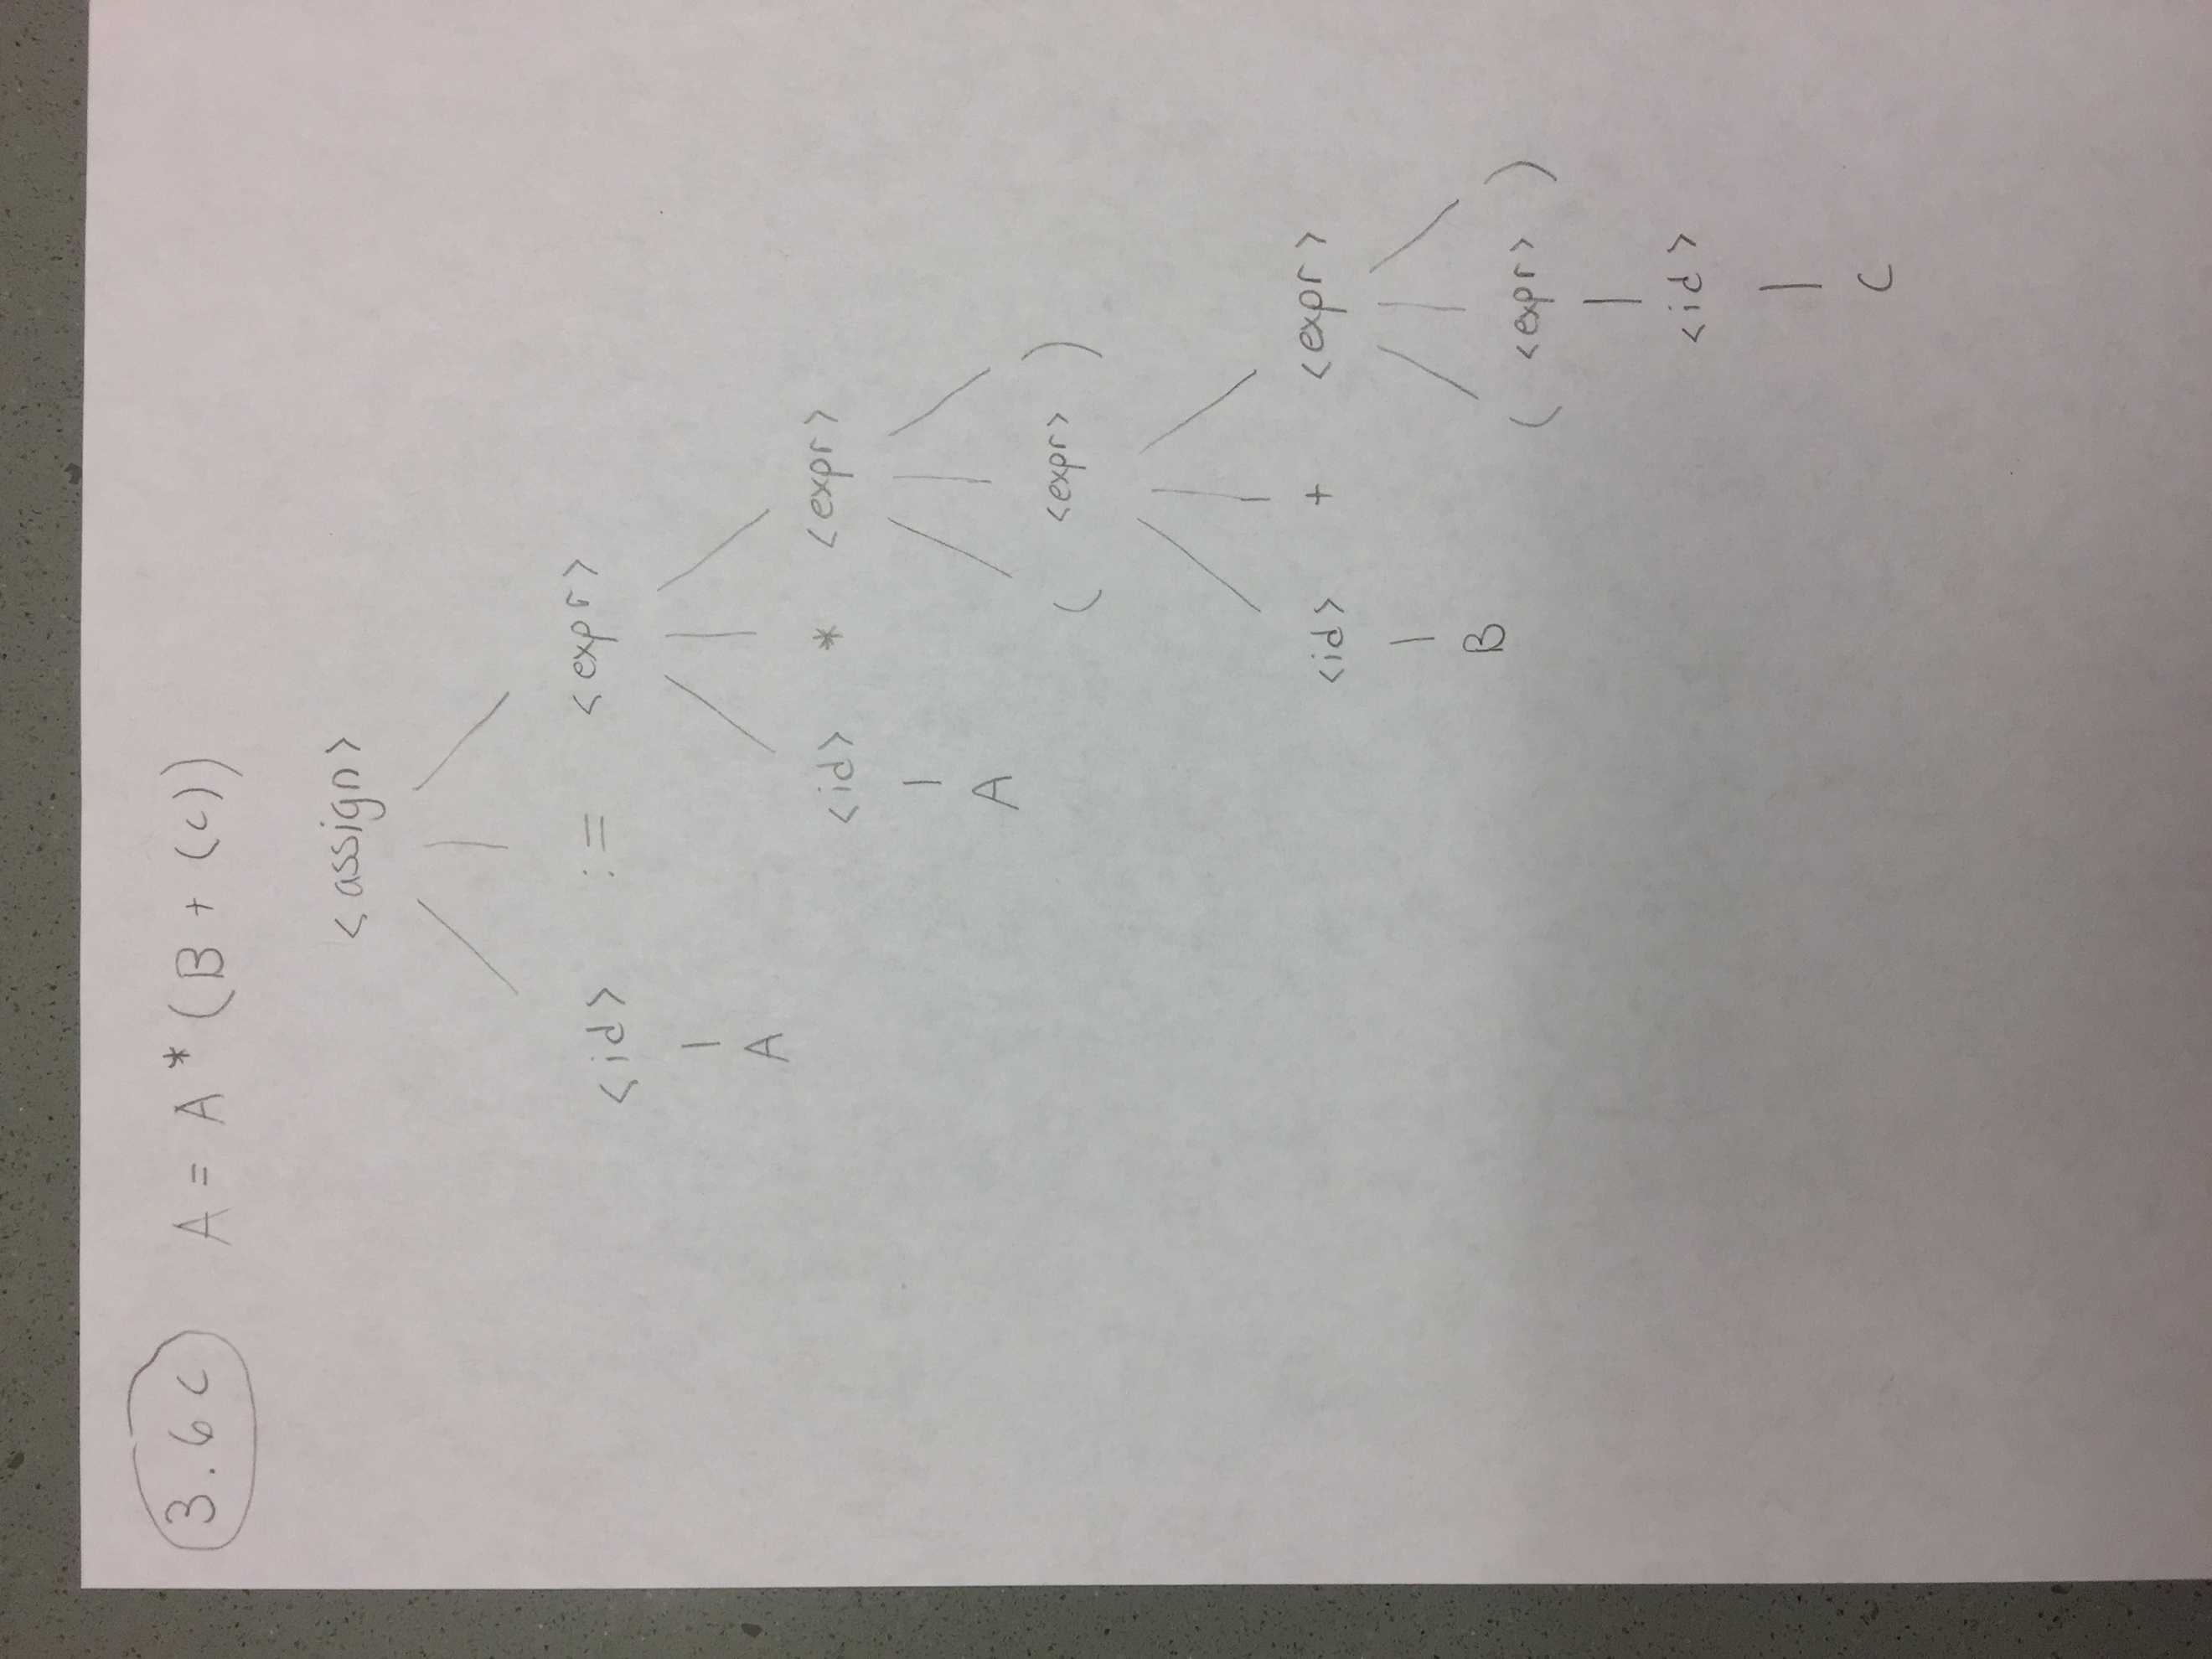

**3.8 Prove that the following grammar is ambiguous:**

**<S> -> <A>**

**<A> -> <A> + <A> | <id>**

**<id> -> a | b | c**

<S>

|

<A>

/ | \

<A> + <A>

/ | \ |

<A> + <A> |

| | |

<id> <id> <id>

| | |

a b c

<S>

|

<A>

/ | \

<A> + <A>

| / | \

<A> + <A>

| | |

<id> <id> <id>

| | |

c a b

**3.12 Consider the following grammar:**

**<S> -> a <S> c <B> | <A> | b**

**<A> -> c <A> | c**

**<B> -> d | <A>**

**Which of the following sentences are in the language generated by this grammar**

The following two sentences can be generated using the grammar above

A. abcd

E. accc

**3.16 Convert the BNF of Example 3.3 to EBNF**

<assign> -> <id> = <expr>

<id> -> A | B | C

<expr> -> <expr> (+ | *) <expr>

| (<expr>

| <id>

**3.21b Use the virtual machine instructions given in Section 3.5.1.1, give an operational semantic definition of the following: Ada for**

i = first

loop: if i < last goto out

…

i = i + 1;

goto loop

out: …

**3.21c Use the virtual machine instructions given in Section 3.5.1.1, give an operational semantic definition of the following: C++ if-then-else**

i = expr1

loop: if expr2 == 0 goto out

…

expr3

goto loop

out: …

**3.22a Write a denotational semantics mapping function for the following statements: Ada for**

Mfor(for var i in init_expr .. final_expr loop L end loop, s)

if VARMAP(i, s) = undef for var

then error

else if Me(init_expr, s) < Me(final_expr, s)

then s

else Ml(while init_expr - 1 <= final_expr do L)

**3.22b Write a denotational semantics mapping function for the following statements: Java do-while**

Mdo(L,s)

Mwhile(repeat L until B)

if Mb(B, s) = undef

then error

else Mwhile(repeat L until B)

**3.24 Compute the weakest precondition for each of the following sequences of assignment statements and their post conditions:**

A. a < 3 & b < 1

B. a > 3 & b > (1 – a)/2

**3.25 Compute the weakest precondition for each of the following selection constructs and their post conditions:**

A. a > 0

B. x < 0

C. x > 2